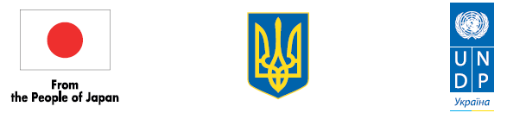

Project 00104483
Economic Recovery and Restoration of Critical Infrastructure
in Eastern Region of Ukraine

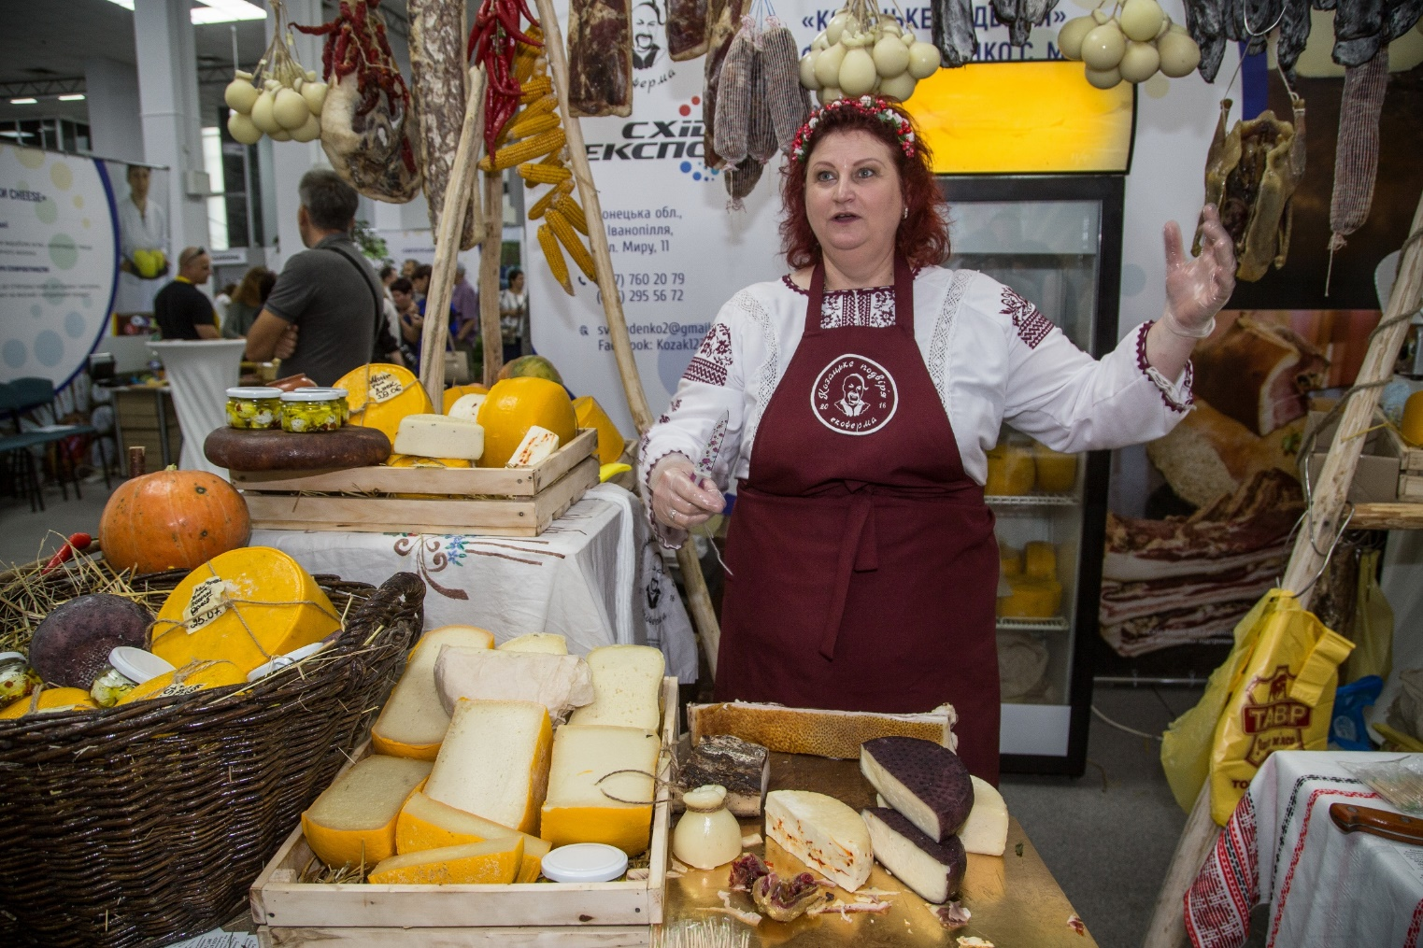
FINAL PROJECT REPORT
March 2017 – February 2018

CONTENTS
Acronyms
- Executive Summary
- Implementation Strategy
- Project Results
- Activity 1: Entrepreneurship Support and Employment Programme
- Activity 2: Restoration of Public Infrastructure
- Communications and Visibility
- Challenges and Risks
- Lessons Learned
- Recommendations
- Annexes
- Annex 1: List of grantees
- Annex 2: Information on beneficiaries
- Annex 3: Map of rehabilitated social and economic infrastructure
- Annex 4: East Expo 2017 participants survey

Project 00104483
Economic Recovery and Restoration of Critical Infrastructure in Eastern Region of Ukraine
FINAL PROJECT REPORT
March 2017 – February 2018
Contacts: Programme manager, Mr. Victor Munteanu
E-mail: victor.munteanu@undp.org

ACRONYMS
PES – Public Employment Service
CSO – Civil Society Organization
GCA – Government Controlled Area
IDP – Internally Displaced Person
LLC – Limited Liability Company
MFA – Ministry of Foreign Affairs
MSMEs – Micro-, small and medium size enterprises
SGP – Small Grants Programme
NGO – Non-governmental Organization
RPP – Recovery and Peacebuilding Programme
SES – State Employment Service of Ukraine
SGP – Small Grants Programme
ToR – Terms of Reference
UNDP – United Nations Development Programme

- EXECUTIVE SUMMARY
The armed conflict in eastern Ukraine has greatly affected every aspect of local communities’ lives. It has had a particularly severe impact on access to livelihoods and customary economic ties in the region. A significant proportion of infrastructures has been damaged or ruined, traditional markets appeared to have closed, and more than a million people have had to leave their homes, losing their jobs and businesses.
To address these issues, UNDP Ukraine collaborated with the Government of Japan to develop and implement the “Economic Recovery and Restoration of Critical Infrastructure in Eastern Region of Ukraine” project. The overall objective of the project was to support local economic recovery, foster employment and create income generation opportunities for the population in the Government-controlled areas in Donetsk and Luhansk Oblasts. As an integral part of UNDP’s wider Recovery and Peacebuilding Programme, the project complemented actions aimed at recovery of social services and support to IDPs in the affected region.
Project included various activities – from rehabilitation of socio-economic infrastructure to provision of financial support to MSMEs and training programmes on entrepreneurship.
Firstly, four important social and economic infrastructure facilities, which are critical for economic and social recovery of the conflict-affected regions, have been rehabilitated in Donetsk and Luhansk Oblasts. Eighty people were temporary employed during the construction works at the four objects. The list of restored facilities includes three water pumping stations and one social services centre. Two of the sites are located in Donetsk oblast and two in Luhansk oblast. In most cases, recovery was needed to improve insufficient technical conditions of the facilities caused by prolonged exploitation.
- Water pumping station in Toretsk city, Donetsk Oblast (40,000 beneficiaries)
- Water pumping station of II level lifting at the Siverskyi Donets-Donbas channel, Orikhovatka village, Donetsk Oblast (1,8 million beneficiaries)
- Water pumping station in Stara Krasnianka village, Luhansk Oblast (60,000 beneficiaries)
- Social Services Center in Novoaidar, Luhansk Oblast (57,000 beneficiaries)
In total around 1,9 million people, including IDPs and local MSMEs, in conflict-affected eastern regions of Ukraine got access to more sustainable water supply. The restoration of water supply systems improved sanitary-hygienic standards for population and reduced technological breakdowns at the local enterprises. In addition to that, some 57,000 residents of Novoaidar town and neighbouring area, including around 15,000 IDPs now have access to wide range of social services for families, minors and elderly people at the local renovated Social Services Center.
Secondly, 668 conflict-affected people improved their professional and entrepreneurial skills, followed by a business grants contest. All eligible applicants willing to start up, re-launch or expand their micro, small or medium size businesses had the chance to receive up to USD 10,000 to implement their business plans. Forty-one new businesses were supported through this programme, which created 109 new jobs for local population and IDPs (51 men, 58 women).
Finally, to promote and create significant visibility to MSMEs with local products and services from Luhansk and Donetsk Oblasts, a Business Expo “East Expo 2017” was held in Kyiv. In total 85 businesses participated and some 2,000 people visited the business expo, which was held as a two-day event in September in the premises of Ukraine’s Chamber of Commerce in Kyiv. Furthermore, 209 people attended three business forums “Let’s work together” which were held in Luhansk and Donetsk Oblasts with the aim to highlight the success stories of UNDP-supported entrepreneurs and promote the concept of business associations among MSMEs in the region.
With a budget of USD 1,005,175 provided by the Government of Japan, actual Project implementation took 12 months. With the expansion of the UNDP Ukraine “Recovery and Peacebuilding Programme”, the Project’s best practices, partnership gains and experience will be applied to ensure further economic recovery in the targeted region. It is planned that the recovery of social services, alongside with support to the local economy and restoration of governance in Donbas, will bring more benefits to the local communities and the peacebuilding process. As the result of this Project:
- Almost two million people benefited from four restored economic and social infrastructure facilities;
- 41 micro, small and medium enterprises launched, recovered or extended their businesses activities;
- 109 people got jobs due to MSMEs support activities;
- 80 people got temporary jobs during the restoration works at the infrastructure facilities;
- 668 people improved their professional and entrepreneurial skills;
- 85 MSMEs promoted through national Business Expo;
- Over 2,200 people attended business exhibitions, forums, workshops, and open discussions on business associations, cooperation between the public and private sectors, success stories in business and other topics.
Therefore, the Project has achieved, and in most of the cases overachieved, its expected results (as per the Project Document) as summarized in the table below.

№ | Indicator | Target | Actual | Comment
1 | Number of public infrastructure facilities restored or rehabilitated | 4 | 4 | Fully achieved
2 | Number of people (women and men) benefitting from restored or rehabilitated infrastructure facilities | 30,000 | 1,957,000  (1,058,900 women  898,100 men) | Overachieved
3 | Number of MSMEs started-up, re-started, or extended their business activities | 40 | 41  (15 women,26 men) | Overachieved
4.1 | Total number of new jobs created for adults (men and women) 15+ years of age | 100 | 109 (51 men, 58 women) | Overachieved
4.2 | Total number of new jobs created during the construction works at the infrastructure facilities | 0 | 80 | Overachieved
5 | Number of people (women and men) improved their professional and entrepreneurial skills | 300 | 668 (324 women, 344 men) | Overachieved

- IMPLEMENTATION STRATEGY
A number of approaches were used to implement the Project to ensure it complied with UNDP’s general principles for recovery and development interventions.
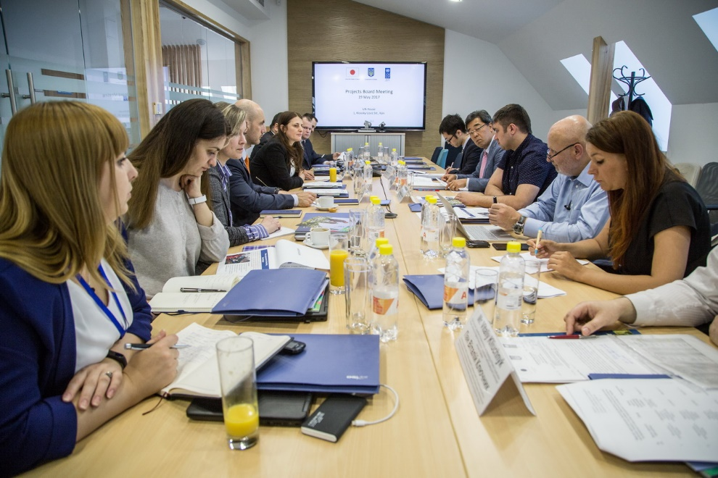
An inclusive approach to identifying and prioritizing the recovery needs
To ensure the most effective use of the Project’s resources, the greatest possible positive impact and local ownership of Project’s results, a participatory strategy was chosen for implementation.
This approach was especially important for the infrastructure rehabilitation component because of the large financial commitments and the time investments they required. Therefore, different interest groups were gradually included in the selection process. Project experts collected detailed information on recovery needs from local authorities at region, district and city levels. At the same time, the priorities for and the feasibility of recovery were discussed with local experts on infrastructure and economic development.
May 2017, representatives of UNDP, Embassy of Japan and Donetsk, Luhansk Oblast State Administrations discuss the project’s first results and further plans
Using the Build Back Better principle
The damages caused by the armed conflict have added to the general unsatisfactory condition of social infrastructure since most of the premises were outdated and badly maintained over the past decades. At the same time, the overload of the facilities caused by the IDPs influx further decreased the quality of services. Hence, the social infrastructure had to be not only recovered but upgraded as well.
The Building Back Better principle has been applied both regarding physical restoration and service provision. The key aim of the Project team was not only to help in restoring economic, social and healthcare infrastructure facilities but to make services they provide more accessible for people, as well as more up-to-date.
Improving energy efficiency
A special case of the “Build Back Better” principle is improving the energy efficiency of the restored infrastructure. Energy saving was not generally a priority in the Soviet era, when most of Donbas’ infrastructure was built. Consequently, installation of energy saving equipment during the recovery work helped both to cut maintenance costs and to better protect the environment. Firstly, the Project procured modern lightening equipment for the recovered facilities. Secondly, energy saving was taken into account during the replacement of machinery. For example, new automatic systems now help to manage the pumps at the recovered water pumping stations in a new way, reducing both energy loss and risks of breakdown.
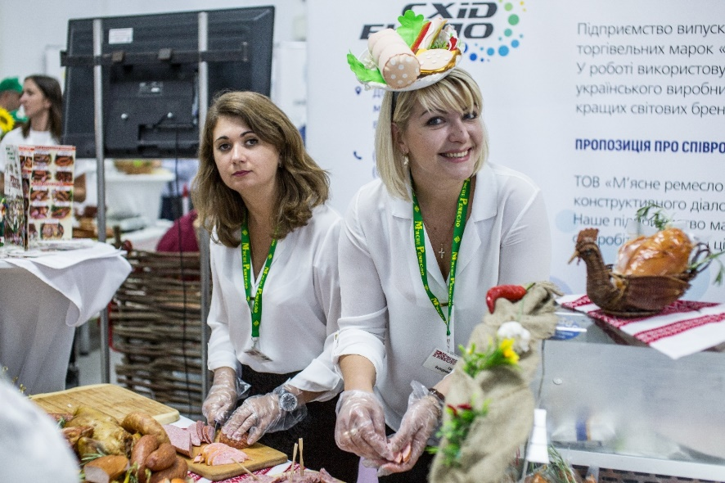
Women’s economic empowerment
The role of women role is often emphasized in the context of peacebuilding for eastern Ukraine, but their contribution to the region’s recovery is often diminished. In terms of physical restoration, women are indeed a minority among the construction workers. At the same time, they play an active role in the economic recovery, actively engaging in employment, re-skilling, upskilling and entrepreneurship development and promotion programmes.
Women entrepreneurs from Donetsk Oblast participating in East Expo in Kyiv.
With inspiration and support from the Project team, women constituted over the half of the participants in the training events,40% of the winners of the grant competition and 53% of all employees hired due to the grants support activities
Sustainability of the results
The nature of a number of the Project activities (e.g. business grants and training programmes) requires thorough follow-up process to ensure the sustainability of the changes. As for physical restoration, sustainability shall be achieved by ensuring the inclusion in local and regional budgets expenses to cover recurring costs following the handover of the facilities. It means that the local communities will include infrastructure maintenance in local and regional budgets to ensure that the recurring costs that follow the reconstruction are covered.

- PROJECT RESULTS
Activity 1: Entrepreneurship Support and Employment Programme
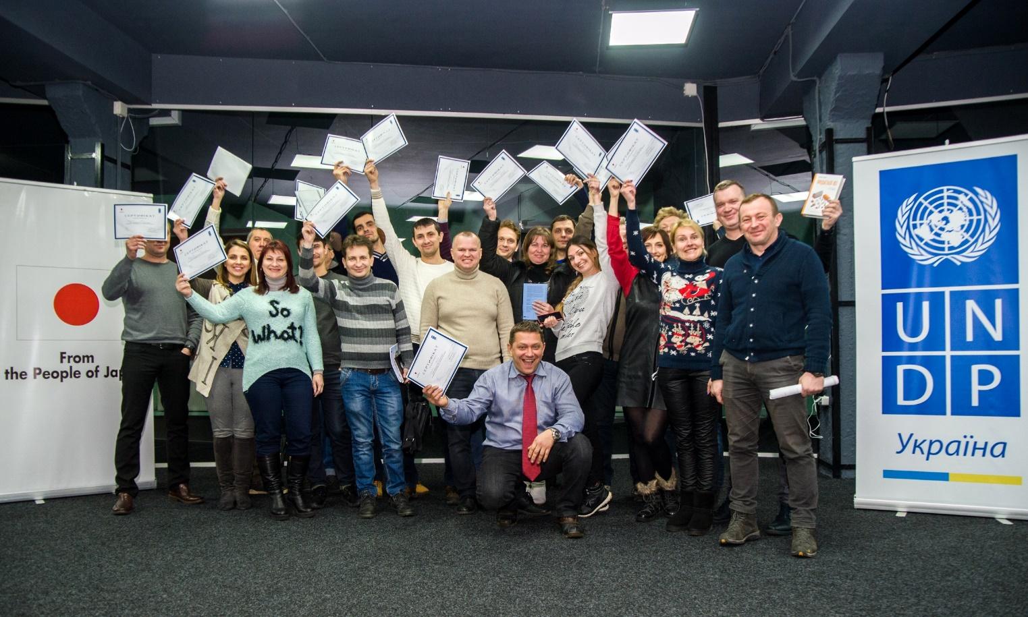
Training on entrepreneurship
Participants of the training course on fundraising for business in Severodonetsk, Luhansk Oblast, February 2018.
Before the conflict, large industrial enterprises fully dominated the Donbas region’s economy. The traditional way to generate income for a person living in this region was to work at one of the large local industrial enterprises, rather than launch a private business. Since local economic ties have changed significantly due to the conflict, this model has become less feasible and attractive, prompting more people to consider small and medium businesses as both their possible occupations and a tool to restore the region’s economy.
To support the entrepreneurial aspirations of the local population, UNDP has launched a series of business skills training events. In partnership with an experienced business training provider, the Project has conducted 31 training events in five cities in Donetsk and Luhansk Oblasts for all those willing to become entrepreneurs or develop a business. The course included lectures and workshops on business planning, legal and registration issues, finance, marketing, fundraising and other business-related topics.
In September 2017 and later in February 2018, a call for registration for the training courses was announced on UNDP Facebook page and announcements were sent out to the regional media, advertisement platforms and various partners, such as Public Employment Service Centres, regional authorities, chambers of commerce. In February 2018, in cooperation with Luhansk Oblast Administration, five training sessions were delivered covering the topics of fundraising for start-ups and existing businesses. The demand for business development training is steadily high and exceeds the number of available places at each training course. The Project forms the waiting list of those willing to participate in the training courses and sends them the notification once the new training is announced.
The online application form with user-friendly design and comprehensive information regarding the training programme and the schedule of training sessions was published on the contractor’s website mba.sbiz.club/undp2017. Upon submitting an application, each participant completed the tailored test to assess his/her entrepreneurship aptitude and motivation. Final selection of participants was based on the results of the test during a telephone interview.
The training courses met the following objectives:
- Motivate the conflict-affected persons to start, re-start or extend their business;
- Strengthen entrepreneurial and management skills;
- Provide information on starting up a business (registration, accounting, legal procedure, marketing, etc.);
- Provide support in the development of business plans to seek external funding (grants, loans, etc.).
As the result of the training activity, in total 668 people (324 women, 344 men) gained new skills and knowledge on how to launch, develop or restore businesses. Some 30% of training graduates applied for UNDP Business Grants Contest and up to 25% of the contest winners are participants of UNDP business development training courses, including training courses on business plans development. The Project launched an email survey to identify number of trainings participants who launched own business without help of any grant.
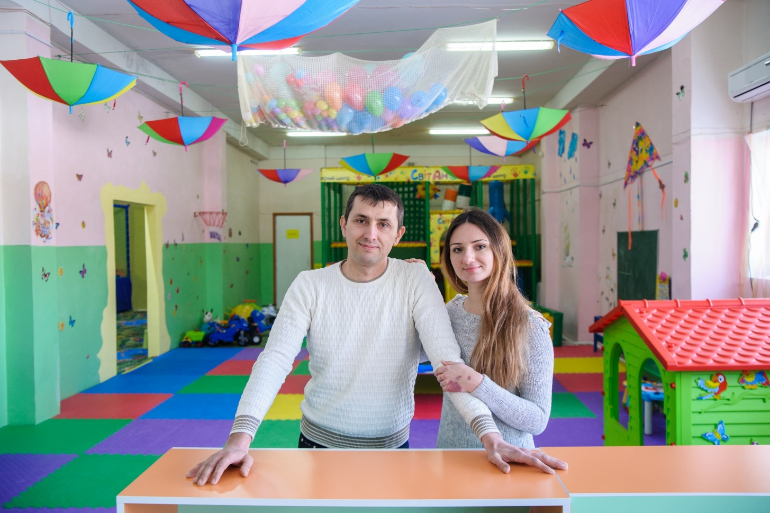
Anton and Svitlana Zinchenko participated in the business development training course held by UNDP and funded by Japan. They decided not to wait until the next round of Business Grants Programme and invested their savings into the family start-up – the biggest children entertainment centre in Rubizhne, Luhansk Oblast. They created three new jobs.
Business Grants Programme
Serhii Gakov, a resident of Donetsk Oblast, is the co-founder of a company that produces 3D printers and creates 3D models of various objects including prosthetic devices for people with disabilities. With a grant from UNDP and the Government of Japan ($ 6,000), the entrepreneur purchased a 3D scanner, which will accelerate the production process and provide greater accuracy in the production of the company’s prosthetic devices.

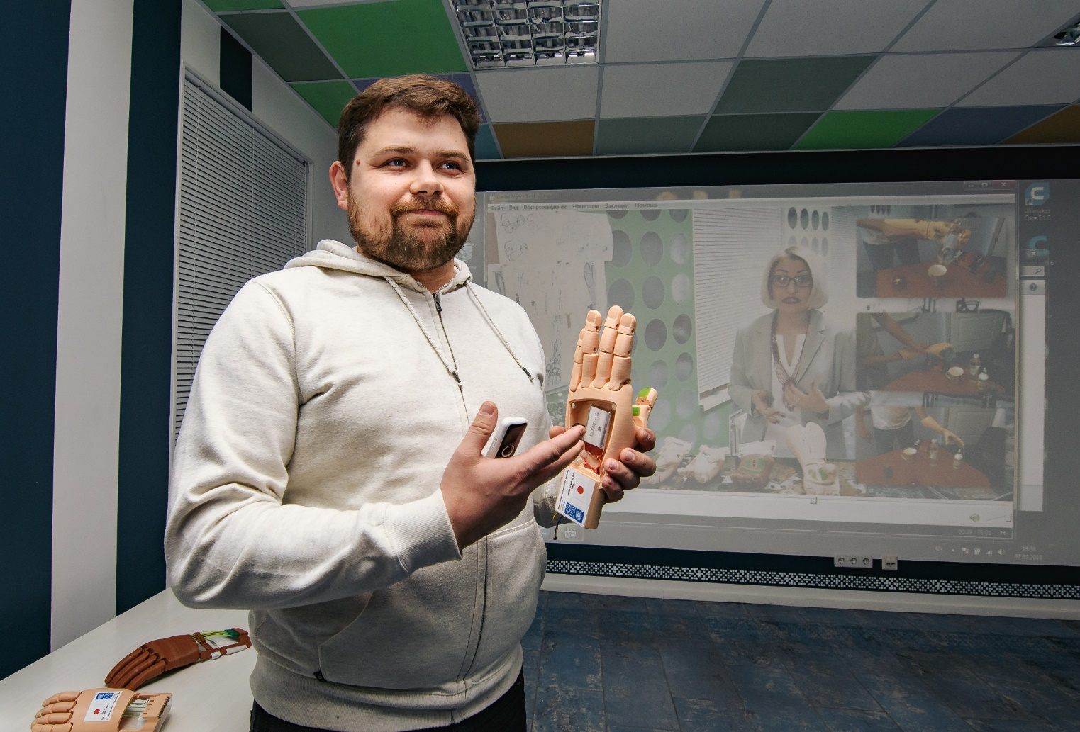
Provision of financial support to those who are willing to launch private enterprises and already have business plans has been instrumental in UNDP’s efforts to promote income-generating opportunities in the region. It has become even more important given that local businesses lack access to loans at reasonable interest rates because of security concerns and high interest rates.
The grant programme was designed to support the launch, recovery or development of micro, small and medium businesses with grants of up to USD 10,000. Applications had to demonstrate a high level of quality, have long-term prospects to generate income, be based on realistic market indicators, and foresee the creation of new employment opportunities and jobs. The sizes of the business grants ranged from USD 3,000 to USD 10,000, depending on the number of jobs created.
The contest was open for all residents of the Government-controlled areas of Donetsk and Luhansk Oblasts, both locals and IDPs. An open call for applications was published on UNDP website, Facebook page and the contractor’s website on 30 July, 2017, followed by numerous reposts by national and regional media outlets. An extensive information campaign was launched to announce the Business Startup Grants Contest.
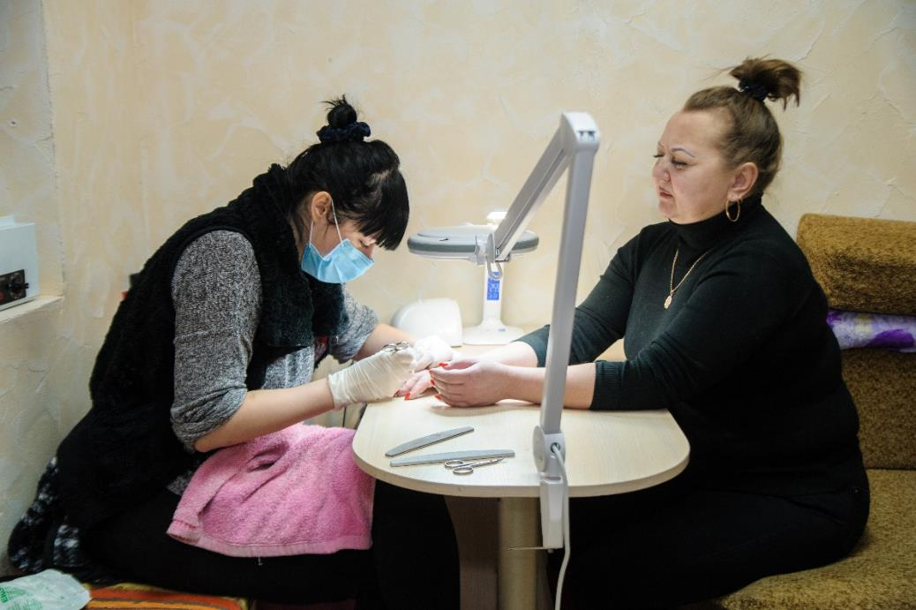
Twelve info-sessions were conducted in 10 cities in Donetsk and Luhansk Oblast which were attended by 429 persons (approximately 60% women). The info-sessions were conducted in Mariupol, Vuhledar, Kostiantynivka, Popasna, Dobropillia, Druzhkivka, Kramatorsk, Severodonetsk, Svatove, Bakhmut.
Olena Stryzhak opened a beauty salon in Popasna, Luhansk Oblast, a town few kilometres from the frontline. In 2014, the building was hit by an artillery shell. With support from UNDP and Japan ($3,000) she restored the premises, recovered her family business and launched new services. The entrepreneur created two jobs.
In total, 948 business plans (618 from Donetsk Oblast, 330 from Luhansk Oblast) have been submitted to the UNDP Business Grants Contest. Of which 60% applications were submitted by men and 40% by women. The technical and quality assessment of business plans was completed by professional business consultants in early October 2017. As a result, 315 applications went forward to the third stage of the evaluation process. At this stage, the qualified applicants presented their business plans in person to the independent Evaluation Committees.
The evaluation committees consisted of seven members, including representatives of the Contractor (the expert, who carried out the evaluation of business plans), UNDP representative (regional coordinator), representatives of local authorities, and regional experts in the field of small business and entrepreneurship.
On 2-7 October 2017, evaluation committee meetings were held in Donetsk and Luhansk regions to assess business plans. As the result, 41 applicants whose business plans envisage creation of 109 jobs were selected to receive grant support from the government of Japan (see the list of grantees in Annex 1). The Evaluation committee also formed a “waiting list” of 120 solid business plans, under which up to 386 new jobs can be created, if additional funding is available.
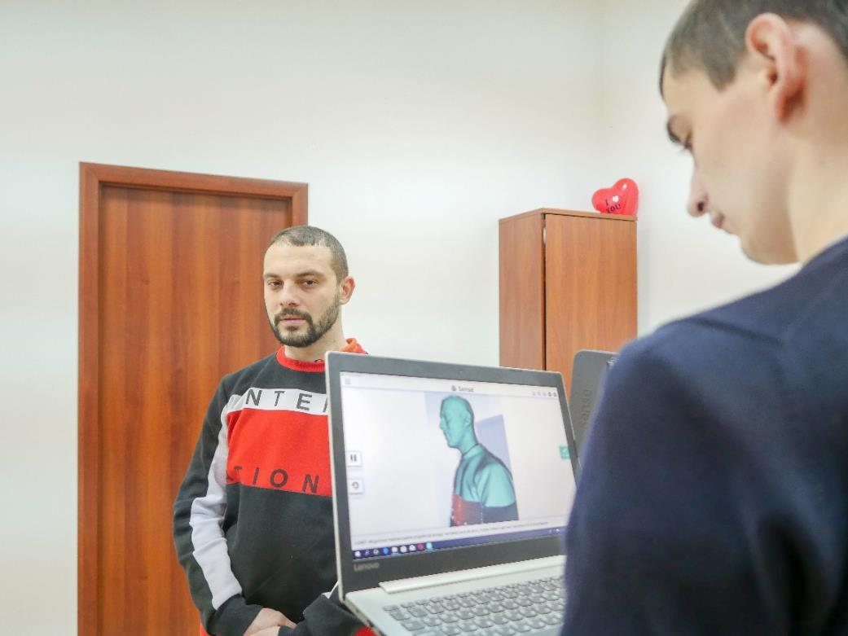
The variety of fields and locations covered in this programme was unprecedented: IDPs from more urbanized Donetsk and Luhansk agglomerations brought with them both demand and new ideas for production of various goods and provision of services. The variety of fields and locations covered by the contest winners is impressive. Some of the most interesting and promising business initiatives supported by UNDP included producing 3D printers, medical centres, web design studios, advertising agencies, architectural firms and a vegan café. Twelve businesses were supported in the areas close to the contact line: Shchastia, Popasna, Stanytsia Luhanska, Hirske, Zolote, Avdiivka. The Project noticed a significant increase of the quality of business plans, development of new niches and interest to the innovation sector. The readiness of MSMEs to take cheap bank loans is steadily growing.
With a grant from UNDP and Japan ($ 6,000), Oleksandr Bondarenko, launched a company that creates 3D models of various objects in Mariupol, Donetsk Oblast. The entrepreneur also provides workshops to train people how to use 3D printers, scanners and other innovative devices. He also created two additional jobs.

The maximum amount of the grant provided to support implementation of a business plan depends on the number of jobs created under this business plan. Successful applicants required to contribute by at least 25% of their business project’s total costs:
- Up to USD 10,000 allocated for the business plans aiming to create at least 4 jobs;
- Up to USD 8,000 allocated for the business plans aiming to create 3 jobs;
- Up to USD 6,000 allocated for the business plans aiming to create 2 jobs;
- Up to USD 3,000 allocated for the business plans aiming to create one job (including self-employment).
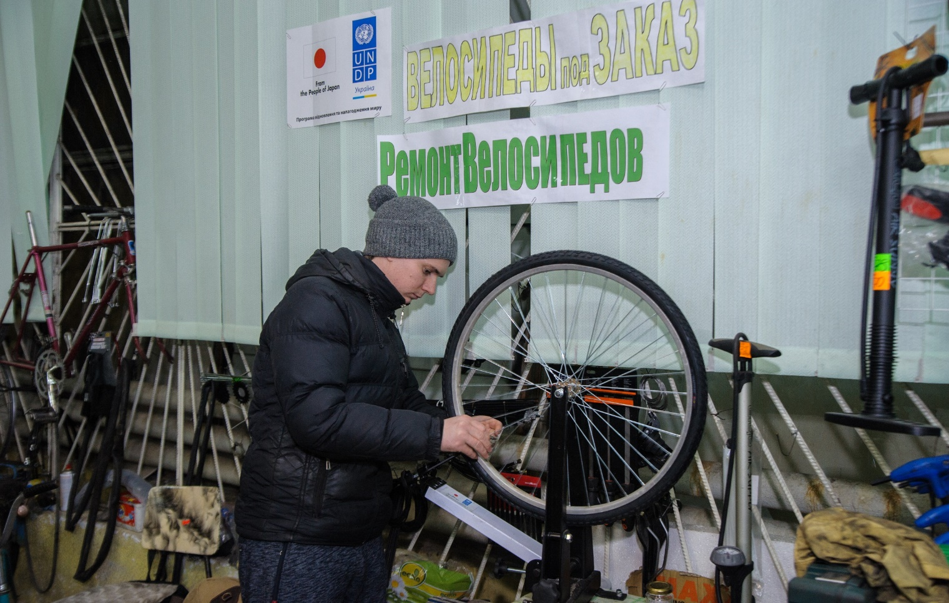
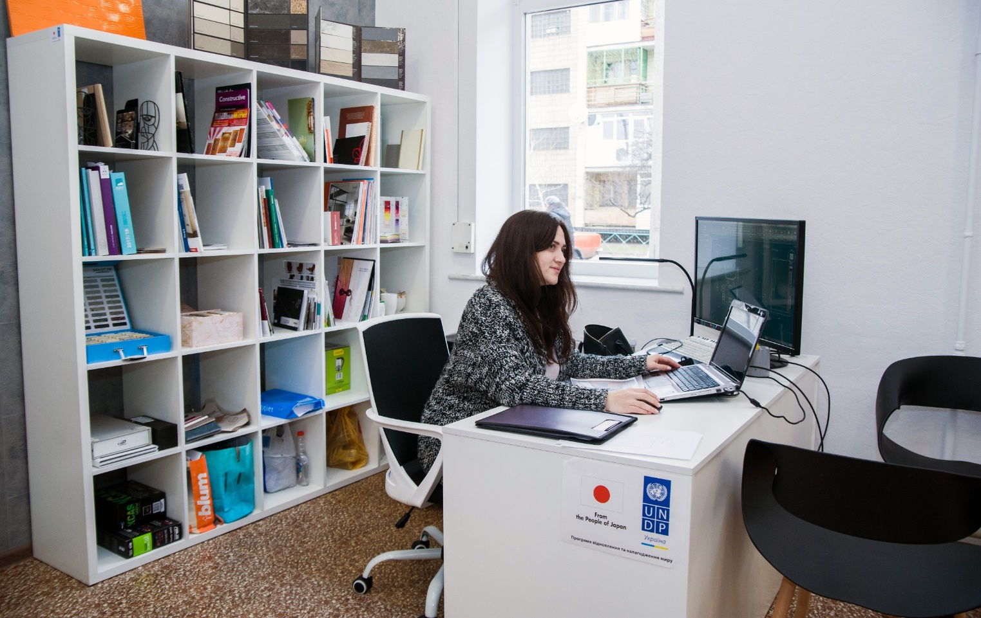
Olena Zozulia studied arts and design in Kyiv. With support from UNDP and the governmnet of Japan ($ 6,000), she opened the first-ever interior design studio in Severodonetsk, Luhansk Oblast. Olena created two new jobs, and already plans to expand her business and hire five more people.
With support from UNDP and Japan ($ 1,600), Artem Ponomarenko opened a bike store and maintenance workshop in Stanytsia Luhanska, Luhansk Oblast. This town is located near the line of contact and has the only in entire Oblast crossing point to the non-government-controlled areas. Historically, bikes have been extremely popular type of transport in this community so Artem’s business filled the niche and provide products and services which have been disrupted due to the conflict.
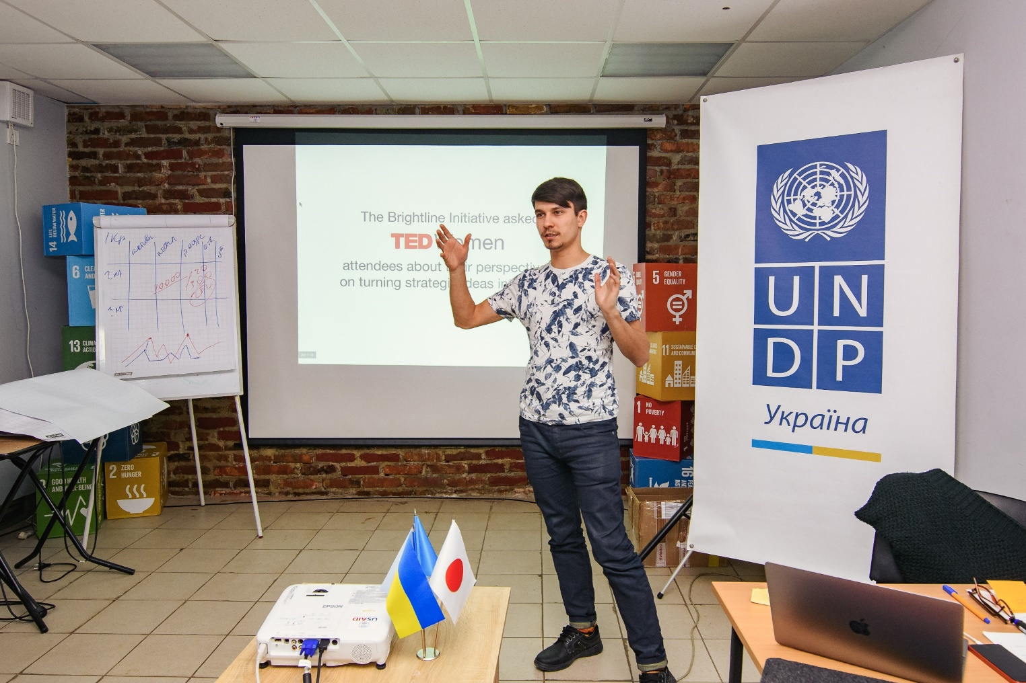
Consulting services
Professional business trainer consults conflict-affected entrepreneurs on fundraising, marketing and communication in business. Kramatorsk, Donetsk Oblast, February 2018.
Another step to support employment and entrepreneurship in conflict-affected communities was the provision of consulting services. The access to services was provided for 41 MSMEs supported by the Government of Japan. These services cover legal counselling on issues such as registration, re-registration, obtaining permits, certificates, counselling on accounting, including bookkeeping, auditing, reporting, etc.; as well as marketing services, focusing on issues such as business and product promotion among customers, using social media, cooperation with mass media, amongst other effective strategies relevant to the context.
Procedures and a mechanism have been designed to record and monitor consultations (a consultation log containing the enterprisers’ names, the number of the voucher for each consultation, the dates of the consultations, their topics and duration). The target group has been informed about possibilities within the Programme on consultations (via e-mail and further informing by phone).
The voucher system for providing consultations has been put into operation and is functioning, the IDPs getting access to legal, accounting, business development and marketing advice. The monitoring system has been developed for the process of voucher delivery of consultations and workshops/group consultations. Three workshops/group consultations conducted in the following cities: Severodonetsk, Kramatorsk, Mariupol. Feedback has been obtained from consulted recipients.

Business promotion
“Cossack farm” company is run by IDPs in the town of Ivanopillya, 50 km away from the contact line in Donetsk Oblast. On 12-13 September 2017, they came to Kyiv to participate in East-Expo to show the whole country that they have plenty of products to propose to the Ukrainian customers.

To promote and create significant visibility to MSMEs with local products and services from Luhansk and Donetsk regions, UNDP initiated Business Expo “East Expo 2017” in Kyiv. The aim was to facilitate business partnerships, ensure visibility and promote expansion of Donbas enterprises outside of the local area as well as to build solid relationships with various local and national business. In total 83 businesses took part in the business expo, which was held as a two-day event on 12-13 September in in Kyiv in the premises of Ukraine’s Chamber of Commerce. These enterprises were listed in an online business catalogue, which was also printed in 50 copies and distributed during the expo.
Not only did small business owners and managers from various industries presented their products and services, but they also took part in peer-to-peer networking, and advanced business training. They also used the event to identify potential partners and find new clients. Through panel discussions, presentations and event features, some 2,000 people visited the business expo and learned about business success stories, innovative technologies, business infrastructure development and opportunities for market expansion in the food, light, fashion and machinery industries (see results of survey provided in Annex 5). Leading business experts and representatives from international organisations shared information about ongoing programmes, services and resources for entrepreneurs in the region. The event received very high visibility in the national media.
The East Expo in Kyiv proved to be not only promotional, but also motivational events for the local entrepreneurs, consumers and residents of both oblasts. The current MSME situation exhibits many limitations in terms of business growth potential, exposure and access to other markets, including limited visibility for local consumers especially in the country’s capital and other regions of Ukraine. In that regard, the Business Expo was a pioneering event, exceeding initial expectations and providing palpable results to all participants.
MSMEs were able to showcase their work in a unique setting and establish connections with other businesses in the two eastern oblasts and beyond. The rate of participation and desire to use the Business Expos as a promotional platform for MSMEs exceeded the expectations. The number of young volunteers assisting with the Expos has also showcased the high interest towards the businesses in eastern Ukraine. A total of 80 (52 women, 28 men) students of regional and Kyiv universities volunteered to help UNDP in organising and running the expo, expressing that the knowledge, skills and inspiration shared during the event have been extremely useful in terms of planning their professional future.
With the aim to highlight the success stories of UNDP-supported entrepreneurs and promote the concept of business associations among MSMEs in Donetsk and Luhansk Oblasts, UNDP held three Business Forums “Let’s work together”. Over two hundred people attended three business forums “Let’s work together” which were held in in Severodonetsk, Kramatorsk and Mariupol in December 2017.
The experts at the Business Forums stressed the need for entrepreneurs to continuously learn, as well as take into account the needs of their clients; as for the activities of business associations - efficient mechanisms of self-regulation and ethical code should be in place, and there should be respect for the principles of integrity. Problems of MSMEs can be better resolved through a business association, even a small one, to voice common concerns.
Short videos showcasing success stories of entrepreneurs in eastern Ukraine were also presented at the forum. These included the stories of a cheese-maker, a landscape designer, a coffee shop owner and a company repairing roads, and 12 more entrepreneurs who are improving the quality of services in their local communities and beyond.

Activity 2: Restoration of Public Infrastructure
To support the revival of businesses activity in the region, UNDP committed to restoring four social and economic infrastructure facilities in the target region. Because of the conflict-related damage and displacement a needs assessment was held to identify the sites for restoration.
The Project experts engaged in a series of consultations with local communities and authorities and conducted a field visit to inspect all suggested facilities. As a result, four infrastructure sites were approved by the Project Board.
The list of restored facilities includes three water pumping stations and one social services centre. Two of the sites are located in Donetsk oblast and two in Luhansk oblast. In most cases, recovery was needed simply because of the technical conditions of the facilities caused by prolonged exploitation.

Water pumping station in Toretsk city, Donetsk Oblast
The city of Toretsk with 40,000 of population critically lacked sustainable water supply which caused deterioration of sanitary-hygienic standards for population and technological breakdowns at the local enterprises. The restoration of this facility was extremely important for the whole Oblast, it allows stable water supply to local population and enterprises. The water pumping station was built in 1957 and due to long-term exploitation and physical demolition was in critical condition and required rehabilitation.
In February 2018, UNDP with the financial support from the government of Japan completed the restoration works. The roof of the building was replaced (507 square metres) and water pumping equipment (centrifugal pump) was re-installed.
The objects’ recovery ensured continuous water supply to the city and area enterprises and population. It also reduced technological risks caused by irregular water delivery at the critical enterprises and reduced cost for maintaining as result of increased energy efficiency of the purchased equipment. The budget for restoration of this facility was USD 71,000.
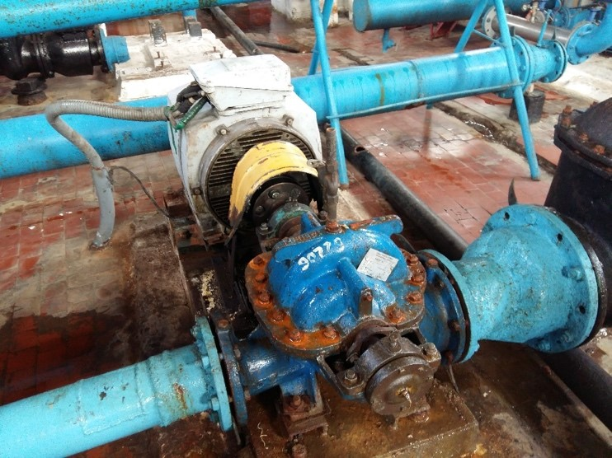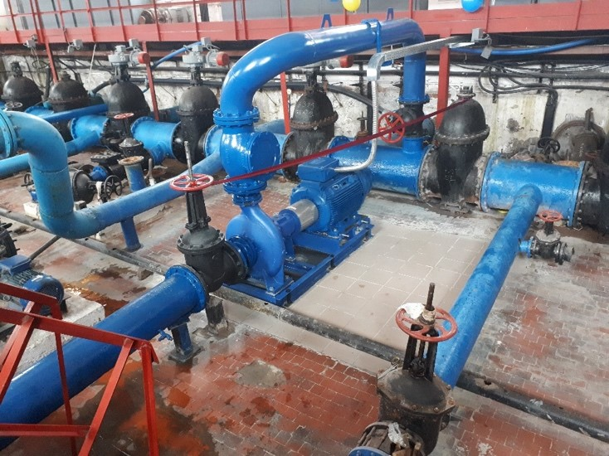
After
Before

Water pumping station of II level lifting at the Siverskyi Donets-Donbas channel, Orikhovatka village, Donetsk Oblast
The water pumping station is a critically important part of complex infrastructure, which support functioning of the Siverskyi Donets-Donbas channel. It supplies water to more than 1,8 million people in the region and to the Sloviansk power station, Kramatorsk city council, municipalities, MSMEs and local agricultural industry.
The station was built in 1957 and needed capital overhaul of premises to ensure a smooth work and functioning of water supply equipment and staff personnel. The following works were carried out on the site: replacement of windows (23 pieces), doors (41 pieces) and gates. Works on internal and external electric lighting was carried out, indoor and outdoor lighting fixtures were replaced and the power convectors repaired (replacement of axial fans).
The object recovery budget was USD 47,700.
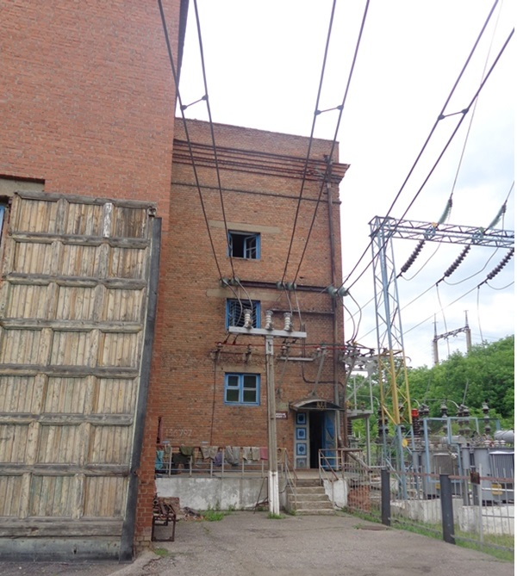
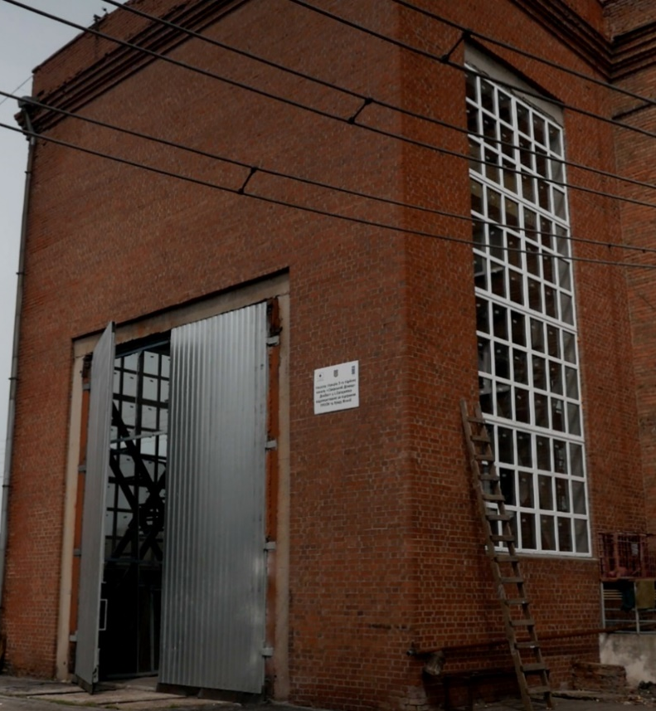
After
Before

Water pumping station in Stara Krasnianka village, Luhansk Oblast
The water pumping station is an important element in water supply system of Kreminna district, Luhansk Oblast. Some 60,000 population in the area, local enterprises (Rubizhne cardboard mill, Rubizhne pipe manufacturer, chemical industry, etc.), and many local MSMEs lacked sustainable water supply which caused deterioration of sanitary-hygienic standards and technological breakdowns at local enterprises.
The pumping station was built in 1985 and required reconstruction, specifically, premises’ overhaul and equipment replacement due to physical demolition. UNDP and the Government of Japan has repaired the building’s roof (146 square metres) and carried out facade works (314 square metres). Windows (4 pieces), doors (12 pieces) and gates were replaced and interior finishing works completed. The system of additional water disinfection was replaced so was the technological equipment and pipelines. Additionally, five convectors and indoor and outdoor lighting were installed. As a result, the pumping capacity of the station was increased to 7,000 cubic metres per day.
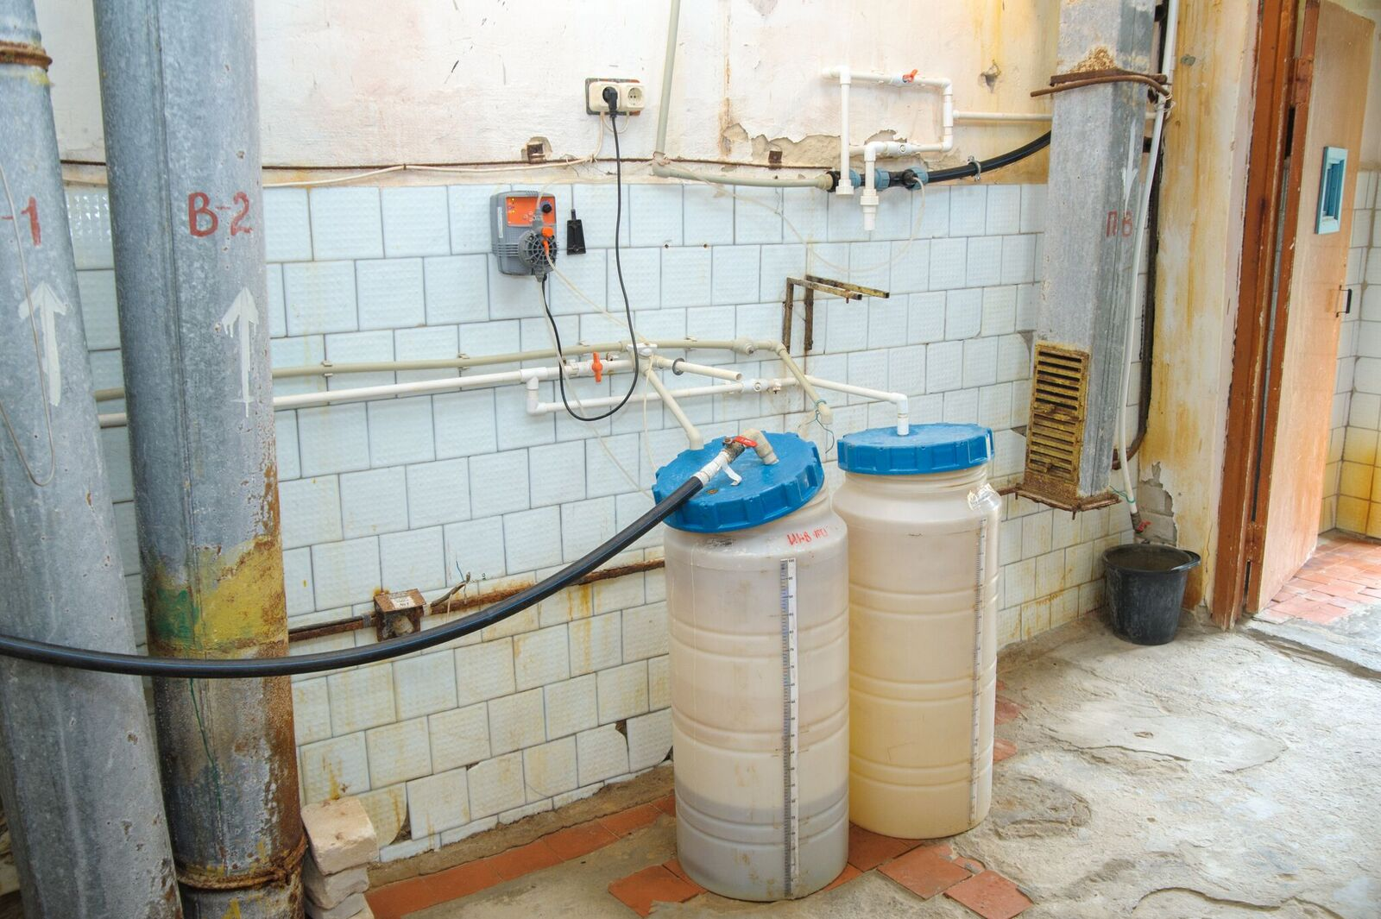
The recovery budget for this facility was USD 46,000.

Before

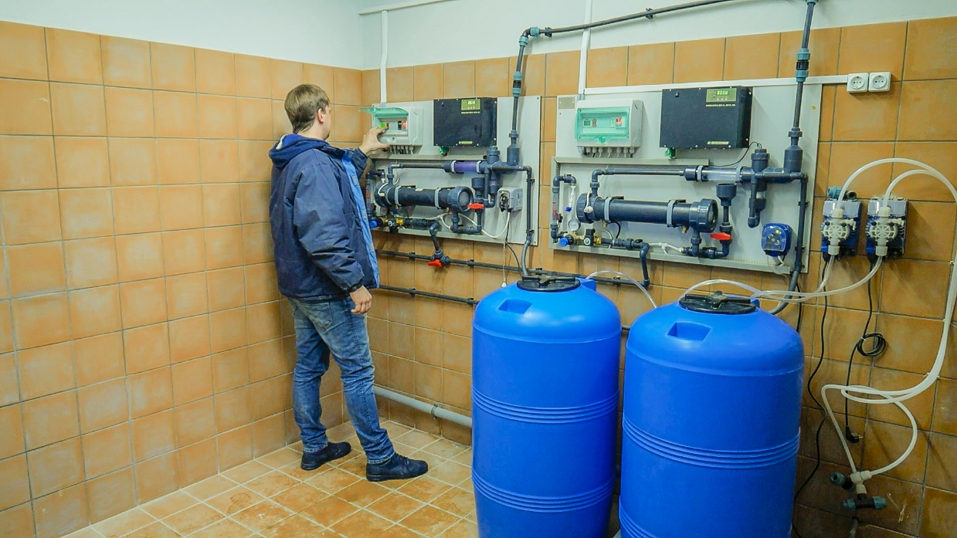

After

Social Services Center in Novoaidar, Luhansk Oblast
The Social Services Center serves for some 57,000 residents of Novoaidar and neighbouring area, including around 15,000 IDPs. It provides wide range of social services for families, minors and elderly people. The building was built in 1965 and required an overhaul and thermal modernization.
In December 2017, UNDP restored and insulated the building’s facade (519 square metres), installed windows (26 pieces). Interior finishing works and installation of indoor lighting were carried out. That helped to improve access to basic social services for local conflict-affected population, including IDPs, to reduce cost for maintaining the facility as result of increased energy efficiency and to increase accessibility of the healthcare institution for people with disabilities.
The object recovery budget amounted USD 28,000.
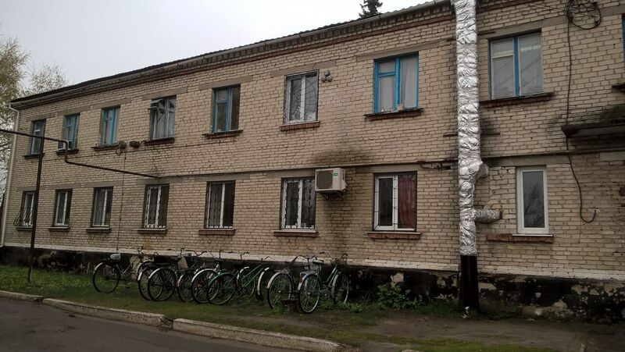

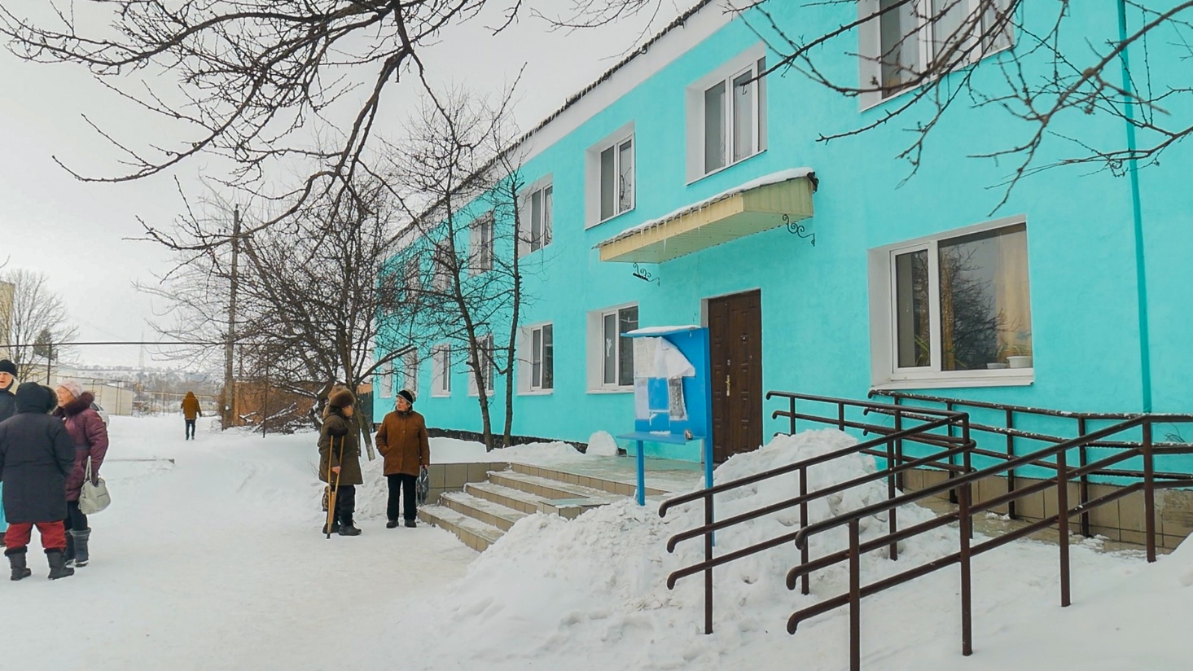
After
Before
COMMUNICATIONS AND VISIBILITY
Communications were a crucial part of project implementation for two reasons. Firstly, the local communities in Donetsk and Luhansk Oblasts still feel the aftermath of the psychological trauma they went through. Reminders of the support that is coming to the region from the international community are yet another way to mitigate the feeling of insecurity and promote reconciliation in local communities and stable development in the region. Secondly, the Government of Japan is making generous commitments to support the people of Ukraine through technical assistance and loans to the Ukrainian Government. Clear visibility for Donor assistance both in the media and during public events has demonstrated the proper use of the funds and ensured general accountability. Therefore, the actual activities were focused on the three main goals outlined below.
An inclusive approach and participation
In order to ensure that the Project actions meet the communities’ needs and lay the ground for future ownership of the results, UNDP made all possible efforts to communicate its plans and progress on infrastructure rehabilitation. Actual participation of local community members and IDPs was also crucial to the promotion of employment and entrepreneurship in the region.
Local media were chosen as a convenient and influential channel to disseminate this information. The tools used for their engagement included official delegation visits, official openings of the restored facilities, dissemination of press releases, interviews with UNDP representatives, and cites visits.
Accountability
Proper use of the recovery and development funds is a topical issue for Donbas. Together with UNDP’s commitment to open and transparent operation, this concern guided Project communications with the local and wider Ukrainian audience, as well as public authorities. It was also important to keep our colleagues and partners in other countries informed about the recovery progress.
Demonstration of support
Information about the assistance that is coming to Donbas from various international donors serves to mitigate the feeling of insecurity that most of the local population experiences. To ensure that joint efforts by UNDP and the Government of Japan are clearly visible, a number of branded items were designed and procured. This includes: banners, flags (large and small formats), signs bearing acknowledgements at the recovered facilities, and stationery used during training, forums and meetings.
Media
Regional, national and international print, online and broadcast media were approached and pitched systematically, including through media briefings, media advisories, press releases, newsletters, and interviews.
Throughout the project’s duration, there were over 200 media mentions (UNDP estimate) of the Japan/UNDP partnership. The milestones were the announcement of training courses in business skills, the launch of the business grants contest, East Expo in Kyiv, and the launch of rehabilitated objects in eastern Ukraine.
The key media outlets covering the project’s activities include:
- National: 5th Channel, Espreso TV, Hromadske TV, Segodnya newspaper, 112 TV channel; 24th Channel; Business magazine, Delo newspaper, Ukrinform, Deutsche Welle Ukraine, ZIK, Golos Ukrainy newspaper, Delo.ua, Gazeta.ua, Facty newspaper.
- Regional: C-Plus TV, UA Donbas TV, Ostrov, Donbas Public TV, Delovoy Sloviansk, Mariupol Express, Donbass Comments, STV channel, Vchasno, sd.ua.

UNDP widely used social media (Twitter, Facebook, and Flickr) to promote the project’s multimedia content, events, success stories and articles. With Facebook being most popular social media platform in Ukraine, an average post would reach 5,000 people. UNDP’s effort to highlight success stories of IDPs and local population in eastern Ukraine resulted in numerous media pitching. For example, Ukrainian national TV channel 112 launched a special project “The Near East” where they cover the stories of entrepreneurs in the East, including UNDP grantees supported by the Government of Japan.

Multimedia content on UNDP-owned online channels
Press releases were issued for every announcement or project launch, milestone or success. In total, 9 original releases, or news stories about Japan/UNDP recovery activities were published on the UNDP website.
- Donbas MSMEs to present business achievements in Kyiv
- Eastern Ukraine opens up new opportunities for business cooperation and investment
- Business grants contest is open for IDPs and Donbas’ local residents
- Women’s run café in Sloviansk brings creativity and coffee together
- Over 70 small businesses get UNDP support in eastern Ukraine in 2017
- A coffee shop that became the city's soul
- Business Trainings for Conflict-Affected Residents of Donbas
- Novoaidar Social Services Centre
- Water Pumping Station in Orikhovatka
- Water Pumping Station in Stara Krasnianka
- Water Pumping Station in Toretsk
Seven video clips promoting East Expo were produced and broadcast via UNDP online channels, screened at intercity trains throughout the country, at the branches of Ukraine’s Chamber of Commerce:
- East Expo 2017 - an exhibition for small and medium enterprises from Ukraine's east
- Workshop about the use of modern information technologies as tools for business development at East Expo 2017
- Workshop about the use of modern information technologies as tools for business development East Expo 2017
- Sustainability of a business idea: workshop at East Expo 2017 by Unit Factory
- Best practices in business: workshop at East Expo 2017 by Pro Business Center
- Getting ready for EastExpo2017 in Kyiv
- East Expo 2017 opening ceremony
- East expo 2017 wrap-up video
CHALLENGES AND RISKS
Currency exchange rate
With exchange rates varying greatly from month to month, prices for material and goods were not stable either. This complicated budgeting for the bidders and negatively influenced the number of bids submitted for large recovery projects.

Safety issues
Most of the Project’s recovery and events sites are located as far as 50-70 kilometres from the contact line. Although no actual security incidents were recorded, possible risks influenced the market greatly. Firstly, the prices for goods and services have risen unpredictably with any changes to the course of the conflict: this further limited the Project’s ability to plan and budget procurement. Secondly, qualified companies occasionally refuse to work in conflict-affected areas because of security issues. This complicated procurement of services that demand specific certification (e.g. reconstruction of bridges). At the same time, this abnormal market situation created favourable conditions for local companies that are ready to work relatively close to the contact line.

Reconstruction timing
Though both national and regional authorities approved Project actions, this did not mean in practice that all the administrative processes necessary for reconstruction work to commence were put on fast track. Since issuing of permits was delayed, the Project could not start the reconstruction works until the winter season had started. After that the works had to be put on hold again because of low temperatures that did not meet the technological requirements.

Staffing issues for MSMEs
Despite huge unemployment rate in the conflict-affected regions of Ukraine, there is a big gap in skills of local unemployed people and those demanded on the regional labour market. Many entrepreneurs emphasize the lack of highly qualified staff for their businesses. Thus, the UNDP training courses contributed to resolving these issues, however, more targeted and advanced vocational training is needed. Such targeted trainings are strongly recommended to be included as activity in the follow-up actions to support economic recovery of conflict-affected regions of Ukraine.

LESSONS LEARNED
- Seasonal factors can have a critical influence on the implementation of infrastructure rehabilitation projects. There are many types of construction work that cannot be carried out when the outside temperature is lower than 5° C or it is raining. Therefore, it is recommended that design and preparatory works be completed during the late autumn and winter period, or construction work is limited to selected core works.
- The feedback collected from the SGP potential grantees shows that additional training sessions on topics related to modern agriculture technologies and agro-processing in rural areas are highly demanded. There is also an opportunity to boost the development of MSMEs by provision of necessary equipment to the already operating businesses (especially to those located close to the contact line) to stimulate creation of new jobs.
- To enhance the impact of SGP and expand business opportunities, it is important to identify and disseminate through various communication channels the success stories to motivate even more people to choose entrepreneurship. At the same time, some of the SGP activities should be targeted at youth to encourage them consider entrepreneurship as an alternative to highly competitive labour market. To maintain the dynamics of new business creation, along with motivational campaigns, trainings on business planning should be held at least once every three weeks in the biggest towns of the target area.
- The analysis of the previous tranches of the Small Grants Programme shows that up to 20-22% of grantees may close their newly-established businesses after the 8-12 months of operation. A significant part of these business failures is related to recent changes in national legislation. The national minimum wage threshold and the unified social tax rate were increased on 1 January 2017 from 1,600 UAH to 3,200 UAH and from 302 UAH to 704 UAH, respectively, and starting from 1 January 2018 to 3,723 UAH and 819 UAH. These legislative changes negatively affected the potential profitability of some business plans submitted for funding. Therefore, many of those plans had to be re-adjusted and updated taking into account the new business environment.
- The above mentioned legislative changes were taken into consideration while evaluating the business plans within the current round of the SGP Contest. The minimum business grant per one new job established was raised from 50,000 to 75,000 UAH, and value of the grant itself is now raised to 250,000 UAH (i.e. equivalent of 10,000 USD).
- An increasing number of people want to start their businesses after they have been informed about success stories of the previously SGP supported businesses. The trend of MSMEs willing to create associations has been also observed to advocate their interests, search for new partners and experience exchange.
- To train successful UNDP grantees as business-trainers and to create a mechanism which would allow them to consult another grantees or start-uppers in the region.
- To create a mechanism to enable young people to pass a paid internship at MSMEs in the region.
It is needed to extend consulting services for the participants of business development training courses who would seek to launch/develop a business without a grant support.

RECOMMENDATIONS
- There is a need to continue and scale up the training programme on entrepreneurship and business development for local population. There is a high demand among the local population in Donetsk and Luhansk Oblasts to participate in the training sessions due to the proved high quality and good visibility of these training activities in the region. The demand for new business training courses would increase due to the ongoing motivation campaign “Big stories of small businesses”, which is expected to reach more than 300,000 people, mainly in eastern Ukraine.
- Access to all kinds of support, including trainings and small grants should be improved for residents of the “grey zone” – the area in maximum 15 km distance from the contact line. UNDP already identified five cases when the participants of the training courses opened successful businesses without grant support from UNDP. The settlements in this area are the most affected by the armed conflict and require presence of businesses in the field of services, repairs, catering and processing of agricultural products. Therefore, it would be reasonable to focus on people from these settlements, using trainings on micro-business. One of mandatory parts of these trainings should be development of business plans that can be implemented independently through self-employment or with support of different international organizations who currently propose grants for business development (from USD 200 to USD 2500) or through regional support programs (such as “Ukrainian kurkul” in Donetsk Oblast).
- It is strongly recommended to develop and launch projects aimed to increase the institutional sustainability of supported businesses. One has to implement periodic monitoring, within 6 months from the date of the grant reception, that would identify training and consulting needs, and barriers to business development. Then, support the expansion of successful businesses, periodic training sessions on business development, marketing and technological innovations should be conducted. Another need is assistance to entrepreneurs in preparation of the business plans and other documentation needed for receiving credit funds or alternative funding.
- It is also strongly advisable to consider developing and launching special financial support mechanism to improve access to loans for MSMEs in conflict-affected areas of eastern Ukraine.
- To sustain the project’s results and promote the positive changes in the MSME sector, it is strongly recommended to continue a systematic organization of workshops on business planning and development as well as promotional events (Business Expos) for producers from the Eastern conflict area. Expertise and best practice exchange in business development is also important for the innovative development of local MSMEs. Conflict-affected beneficiaries who are looking for promising business ideas, as well as those who already have a business idea, but exploring ways for its launching, benefit from participating in experience exchange visits to similar business entities. These types of activities are recommended to be included in the follow-up actions.
- The MSMEs supported by the project, representing a similar industry or regional cluster, demonstrated the tendency to cooperate among themselves and create added value chains. It is recommended to enhance this effect through additional support tools. It is recommended to conduct systematic surveys of the business development status quo, assessing challenges and barriers to business development. These surveys would ensure a timely consideration of existing challenges and an ensuing improvement of the quality of business support. Thus, it is recommended to identify cluster initiatives in traditional industries at the city/district level, looking to create new business niches for MSMEs in the region, as well as to identify business niches which have the potential to sell goods and services outside the region, given the low purchasing capacity of the local population. The support of concessional lending for grantees, who demonstrate growth and readiness to expand their business and create new jobs, would also prove highly beneficial.

